Only comment is should one of the brokers be involved in this discussion? I suggest that Chris be kept in the loop and he may suggest one of his team works with Henry on this.

Annette

From: Andrew Harkins
Sent: Thursday, June 15, 2006 9:09 AM
To: Henry Most; Andrew Harkins; David Herrick; Annette Kelley; Nancy Purcell; Susan Anstrand
Subject: List Markets

Henry and I met today to start the Requirements Gathering process for the List Markets project. Below are current notes. Please participate in this dialogue if you feel we are off-mark or missing critical issues.

Thanks.

General Logic
We discussed creating a system where each Datacard could have the following:
- 1 “Broad” List Market designation
- 1 “Sub” List Market designation
  - This “Sub” would be a child record of the “Broad”
  - Selection of “Sub” would be based off of possibilities under “Broad” – meaning, each “Broad” may have its’ own unique set of “Sub” designations
- 1 “Environmental” List Market designation
- 1 “Political” List Market designation
- (Other List Market designations as needed)

Each List Market category would have a maximum of one designation. There would be no “multiple” designations, nor would we provide possibility of tiers. The idea is to make it as simple as possible in order to maintain ease of use.

At this point, it looks like I.S. would develop:
- An interface to maintain the List Market designations (independent of Datacard association).
- An interface within P4 to maintain the List Market association.
- A List Market designation Initialization program, that will take an Excel spreadsheet developed by Henry and create the initial database.
- Reporting options – probably in Excel.

Datacards
In order to get started, I am going to pull a set of Datacards for Henry so he can develop what might work for him in Excel, and then take his R&D work and fine tune any proposed database/application design.

I will pull 2,000+- Datacards using a variation of criteria used for the website: All Datacards updated within last 2 years that have not been marked “Withdrawn”, “Temp. Withdrawn” or “Office Use Only”.

This criterion will eventually create the listing used by Henry in creating the initial database.

Another option might be to use the criteria used for Usage:
- For List Universes <= 20,000
  - 1 Live/Billed Order in Last 12 months & 1 Additional Live/Billed Order in Last 18 months.
- For List Universes over 20,000
  - 1 Live/Billed Order w/Qty >= 5,000 in Last 12 months & 2 Additional Live/Billed Orders w/Qty >= 5,000 in Last 18 months.
  - 1 Live/Billed Order w/Qty >= 10,000 in Last 12 months & 1 Additional Live/Billed Order w/Qty >= 5,000 in Last 18 months.
  - 1 Live/Billed Order w/Qty >= 50,000 in Last 12 months & 1 Additional Live/Billed Order w/Qty >= 10,000 in Last 24 months.

If you have a preference, please voice it.

Other Items
I spoke with DH about legacy code that may be useful to look at. He mentioned Category designation for both the current Datacard system and an old process established for the Mailer file.

Datacard Category system
Multiple Categories can currently be associated with individual Datacards. There are 3 sub-headings: Business, Consumer & Enhanced. Each sub-heading has its’ own variety of actual Category names. Audrey & Carol currently determine which Categories apply to each Datacard. Evidently Sales would occasionally have I.S. pull reports using these Categories designations. Given our current staff make-up, I guess this is not much used at this point.
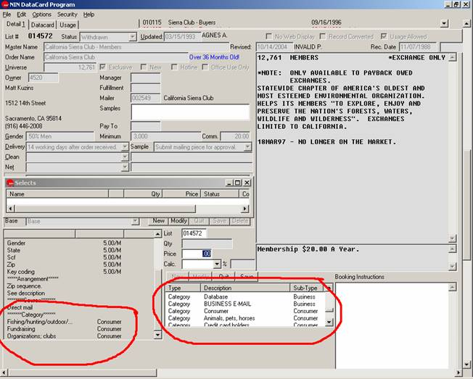

Mailer Category system
There is a legacy system that allowed Mailer Category association. The Mailer Category file is still live, but the only program which currently accesses it is a print program. No system seems to actually update/maintain these associations.

Mailer Categories on this legacy system are as follows:
Non profit
Association
Catalog
Subscriber
Compiled
General Communication
Environmental
Wildlife
Animal(pet)
Outdoor/Nature
Travel/Leisure
Receation/Sports
Health/Fitness
Internation Relief
Domestic Relief
Health Causes
Hospitals
Veterans
Human/Civil Rights
Consumer/Health Rights
Choice/Population
Peace
Political Committee
Political Candidate
General Progressive agenda
General Religious/Conservative Agenda
Non-Partisan Political Issue
Public TV/Radio
Zoos/Aquariums/Gardens
Visual Arts
Civic Cultural Arts
General Music
Book/Literature
Science/Technology
Education
Clothing
Food
Kitchen/Housewares/Home Furnishings
Garden
Collectibles
Crafts/Hobbies
General Merchandise
Finance/Economics
High Brow
Business
General News
New Age
Jewish
Christian/Catholic
Black
Native American
Women
Men
Children's
Seniors
Regional
Lesbian/Gay

Ideas
If a Category system for Mailers is developed, it may be prudent to tie to Datacard. Note this may limit Datacard Category specificity as one Mailer may have several Datacards that have different nuances.

Andrew Harkins

